Pokhara University

Level: Bachelor | Semester – Spring | Year : 2007
Programme: BE |  | Full Marks: 100
Course: Mathematical Foundation of Computer Science |  | Time : 3hrs.

Candidates are required to give their answers in their own words as far as practicable.
The figures in the margin indicate full marks.

Attempt all the questions.

 | - Prove that: If G is a connected graph and every vertex has even degree, then there is an Euler circuit in G.  - Write an algorithm to find the length of the shortest path from initial vertex to final vertex in a weighted graph. | 7  8
 | - What is tautology? Verify that the following is tautology:  - Verify that the following argument is valid by using rules of inferences:  If Clinton does not live in France, then he does not speak French. Clinton does not drive a Datsun. If Clinton lives in France, the he rides a motorcycle. Either Clinton speaks French, or he drives a Datsun. Hence, Clinton rides a motorcycle. | 7  8
 | - Determine the truth-value of the following statement:  For every x, for some y, if 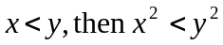.  The domain of discourse is the set of real numbers. Justify your answer.  - Prove by mathematical induction that the following expression holds true for all integer values of 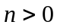  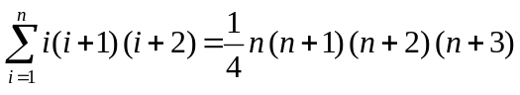 | 7  8
 | - Find an explicit formula for the maximum number of moves 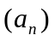in the problem of Tower of Hanoii puzzle, where n disks are used. The recurrence relation was established in the form of 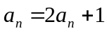with the initial condition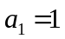.  - Assume that a person invests an amount of Rs. 360000 @ 20% annual interest compounded at the end of every two months. Let A_{n} represent the amount at the end of n years. Find a recurrence relation for the sequence A₀, A₁, A₂,… and find explicit formula for A_{n}. Also, find what will be the amount at the end of 15 years? | 7  8
 | - Construct an incidence matrix I from the following adjacency matrix  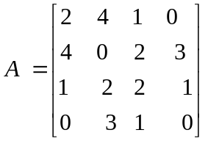  Also, find the number of loops and multiple edges in a multiple graph G.  - Construct a multiple graph G from the following floor plan of a house with various door ways leading between rooms, and between several rooms and the outside. Also, find whether or not the graph G can be Eulerian? Illustrate with clear justification.  A  B  C  D  E | 7  8
 | - Construct a Finite Automata accepting all and only the strings of 0's and 1's that end in 01. Also, give the regular expression for the above language.  - Determine whether the following grammar is context sensitive context tree, regular or none of these. Give all characterization that applies.  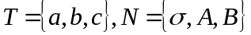, with productions 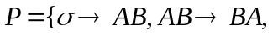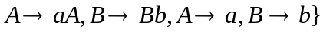 and starting symbol. | 7  8
 | Write short notes on (Any Two):  - Bipartite graph versus Complete Bipartite graph  - Modus Ponens versus Modus Tollens  - Alphabets versus Strings  - Proof by resolution and proof by using interference rule | 2×5

